IEP-IPP v1.0
Administrators Documentation
V1.0 - Monday, February 19, 2007.

IEP-IPP Information and Credits 3
Document Scope 4
Logging in 4
Main Screen 4
General Navigation 5
Top and Bottom Navigation Bars 5
Home Button 6
Back Button 6
About Button 6
Student Button 6
View PDF Button 6
Logout Button 6
Warnings and Errors 6
Change Password Screen 6
Permissions Overview 7
Global Permissions 7
Login 7
Teaching Assistant 7
Teacher 7
Vice Principals & Principals 8
Assistant Administrators 8
Administrators 8
Super Administrator 8
Local Administrator Permission 8
Program Plan Permissions 9
Read 9
Write 9
Assign 10
User Management 10
Adding Users 10
Editing Users 10
Deleting Users & Assigning ‘Local Administrator’ Access 11
The Archives 12
Goals Database 13
‘Super Administrator’ only Features 13
School Management 13
Manage Program Plan Codes 14
License and Version 15

IEP-IPP Information and Credits

The IEP-IPP system originated from the hard work and vision of the special education, information services, and administration staff at ‘Grasslands Public Schools’, which serves the area surrounding Brooks, Alberta.

Many people were involved in this version of the system in the areas of design, testing, administration, and implementation.

Document Scope

This document is intended for IEP-IPP ‘site based administrators’ and ‘administrators’ to provide instructions on user and program plan management for the IEP-IPP system. General users should refer to the ‘User Manual’ for instructions on entering students and managing program plans. Systems administrators should refer to the ‘Installation Documentation’ for instructions on installing the IEP-IPP system.

Logging in

IEP-IPP is an entirely web based application, accessible through either Internet Explorer or Firefox browsers. If you haven’t already been given the information to access IEP-IPP you need to ask your IEP-IPP Systems Administrator or Special Education Coordinator to provide you with both the web address for IEP-IPP and a username and password to access the system.
Open your favorite web browser. IEP-IPP works with both Internet Explorer and Firefox browsers.

Login with the username and password that you were provided.

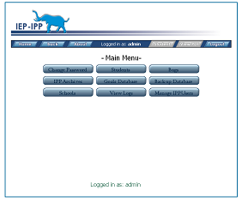
Main Screen

From the main screen you can navigate to all areas that your IEP-IPP administrator has given you access to.

All users have at least the ability to change passwords, and access the current student IEP/IPP pages, and archived IEP/IPP records.

Depending upon the access your IEP-IPP systems administrator has given you, you may also have access to add schools to the system, manage system users, view system log files, and manage a goals database.

Buttons on the navigation bar on the main screen are blue (active) or gray (inactive) based upon the actions that are available, and your assigned permission levels on the page.

General Navigation

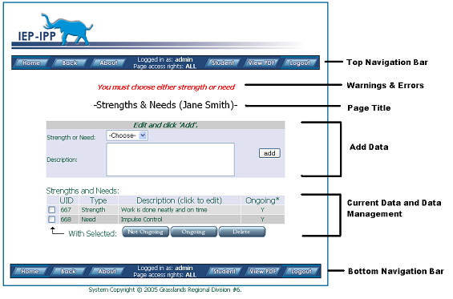

Top and Bottom Navigation Bars

The top and bottom navigation bars allow you to navigate the system. Buttons are blue when active and gray when they are inactive on a screen or you do not have permission. When working within a student’s program plan area, the ‘View PDF’ button is available which gives you an immediate snapshot of the current program plan. Use the navigation buttons built into IEP-IPP. Using the navigation buttons built into your browser can cause problems like duplicate data being entered- this is a limitation of the HTTP protocol and nothing that can be corrected within the program plan software.

Home Button
The home button takes you to the ‘main’ page.

Back Button
The back button typically takes you to the previously viewed page. Some pages, the back button takes you to the parent page.

About Button
The ‘about’ button provides information on the IEP-IPP program, submitting bugs and making suggestions for future improvement on the program.

Student Button
When within the context of an individual program plan, the student button will return you to the main page for the program plan.

View PDF Button
When within the context of an individual program plan, the ‘view PDF’ button will produce the current program plan in a portable document format (PDF) which can then be saved or printed.

Logout Button
The logout button will log you out of the system. If you do not logout, the system will automatically log you out after a certain amount of inactivity on the system, as determined by your IEP-IPP systems administrator.

Warnings and Errors

Warnings and errors are typically displayed under top navigation bar and above the ‘Page Title’. They typically warn about format errors in dates, and missing required fields. When you enter information, check that it shows up in the ‘Current Data and Data Management’ area and that no warnings were produced.

Change Password Screen
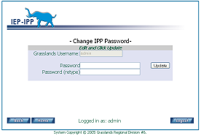

If your school is using the built-in username and password option, the change password button appears on the ‘home’ screen. To change your password enter it the same in both text fields and click the update button.

Permissions Overview

Due to the sensitive nature of the data within the system, there are three levels of permissions. ‘Global Permissions’ are system wide permissions that determine overall access to things like who can add schools, view all program plans within the organization, etc. Global permissions override ‘Program Plan Permissions’ which are permissions that determine access to support members of an individual program plan. The third type of permission is a special type of permission called ‘Local Administrator’ allows a leader at each site to oversee user and program plan management locally.

Global Permissions

There are eight levels of global permissions:

Login

Users with ‘Login’ rights have basic login privileges only and they are able to change their password. This level is intended for future functionality to allow parents ‘real-time’ access to their child’s program plans.

Teaching Assistant

This level provides basic login privileges. A person with this level of access will only see a list of program plans to which they’ve been explicitly added as a support member. They can read, write, or assign others access (depending on the ‘Program Plan Permission’ level granted) to student program plans to which they’ve explicitly been added as a support member.

Teacher

This level of permission can see a list of all students at the site they are currently set at. Teacher level permission will allow a person to create program plans and assign others to be part of the students support group. Only teachers and teaching assistants added to a program plans support member list can access, and write to program plans.

Vice Principals & Principals

These two levels of permission have equivalent levels of access. The distinction is made for any future functionality. Currently both levels can read, write, and assign permissions to all program plans within their site regardless of whether they have been granted ‘Program Plan Permissions’ to an individual program plan.

Assistant Administrators

This level of permission has global read access to all program plans in the system and further access to program plans based on assigned ‘Program Plan Permissions’. This level is intended to allow staff members such as district psychologists the access they need to program plans. This level of access can also add and remove information for the Goals and Objectives database.

Administrators

This level of permission has global read, write, and assign access to all program plans in the system regardless of the assigned ‘Program Plan Permissions’. This level of permission is intended for staff such as superintendents of special education and superintendents.

Super Administrator

This level of permission has global read, write, and assign access to all program plans in the system. These levels of permission can add/remove information in the Goals and Objectives database, manage users at all sites, view system logs, manage the coding database, and add/remove schools.

Local Administrator Permission

This permission is designed to allow site-based leaders to manage the program plans within the site. This person has read, write, and assign level permissions to all program plans within their site. This person can add a new systems member to the systems (at the teacher level or lower), and can change passwords for all staff at their site. In addition, if the mail function has been configured, these people will receive email notifications of program plans that have been transferred into their site from other sites within the system.

Program Plan Permissions

Permissions can be granted on a program plan basis. When a person is added to a students program plan as a ‘support member’, this person is granted permission to the program plan itself. This person can be located at the same site as the student or at a different site. There are three types of ‘Program Plan Permissions’:

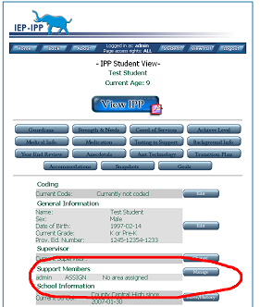

Read

A person assigned ‘read’ permissions is able to read the program plan but isn’t allowed to change or write any data to a program plan.

Write

People assigned ‘write’ permissions can read, write, and modify data in an individual program plan

Assign

‘Assign level permissions allow a person to read, write, modify, and assign others permission to the individual program plan.

User Management

User management is the responsibility of ‘local administrators’ and IEP-IPP systems administrators.

Adding Users
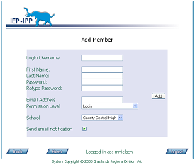

If you have sufficient rights you can add users by clicking on the ‘Manage Users’ button from the main page. At the top of the ‘Manage Users’ page is a new member button. By clicking on this button you are able to fill in their user information. If you are a ‘local administrator’ you will only be able to add a user to your school.

If your system has email notifications enabled, by checking the send email notification button will send the new user an email notifying them of their system account and login information.

Editing Users

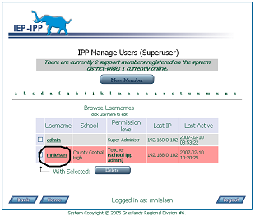
If you have sufficient rights, you can edit user information such as their schools and email addresses.

‘Local Administrators’ are able to edit staff at their site; ‘Administrators’ can edit all user accounts within the system.

Deleting Users & Assigning ‘Local Administrator’ Access

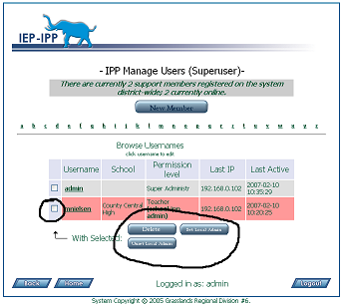

‘Local Administrators’ can delete user accounts within their schools. ‘Administrators’ can delete staff throughout the system and assign ‘Local Administrator’ rights.

To delete or assign ‘Local Administrator’ access check the checkboxes next to the users name that you would like to perform the action on. Multiple names can be selected at one. Click the appropriate action button.

‘Local Administrator’ staff will be highlighted in red.

A deleted account will not remove permissions from program plans. If the same user is entered into the system, access to the program plans will be restored unless they are manually deleted from each program plan. This was intentionally done to prevent a lot of work restoring mistakenly deleted accounts.
Changing User Passwords

On the ‘Mange User’ screen you can get to the ‘Manage Member’ page by click on the username of the person whom you need to change a password for.

Once on the ‘Manage Member’ page there is a change password button. ‘Local Administrators’ can change passwords only at their school. ‘Administrators’ can change passwords system wide.

The Archives

When a student no longer has an active school, they are automatically moved to the systems archives. If you have sufficient rights you can access the student archives to retrieve students who were accidentally moved there or who have returned to school and need their program plans reactivated. ‘Local Administrators’ and ‘Administrators’ can return a student from the archives.

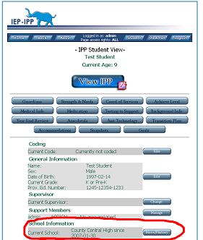

In an archived program plan, click the ‘Move/History’ button to access school information. From the ‘School History’ page simply use the ‘move student within the district’ form to move the student to the school they should be in.

If email notifications are setup on your system, the ‘local administrator’ for this school should receive an email notifying them of the move. They will have to setup the appropriate ‘Program Plan Permissions’ to allow the appropriate people access to the program plan.

Goals Database

The optional goals database provides hints for people creating program plans. Only ‘Administrators’ for the system can edit and add to the Goals Database. The database is a hierarchy of Program Areas (which must exist and a standard set is provided by default during installation), Goals, and Objectives to obtain the goals.

You do not need to provide goals and objectives for the system to be functional. This section is designed to allow for a convenience in creating program plans. Once created, the Goals and Objectives will be displayed in the ‘popup chooser’ on the program plan goals and objectives pages. Program plan support members and supervisors are able to create their own goals within the program plans.

‘Super Administrator’ only Features

Features available only to the ‘superusers’ of the system include school management, coding management, and access to the error logs.

School Management
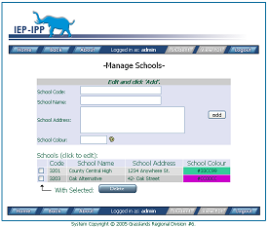
From the main page if you click on the ‘Schools’ button you are able to add, edit, and remove schools from the system.

Enter the school code for the school, school name, address, and choose a school colour.

School colours are designed to allow better readability in lists of students when the user has access to multiple schools.

To delete a school, simple check the checkbox next to the school code and click on the delete button.

Manage Program Plan Codes

From the ‘home’ page you can manage the coding structure for your area. With the default installation, currently, the codes are for the province of Alberta. Codes consist of a code number (which must be a number) and a human readable, and concise (less than 255 characters) description of the code.

License and Version

IEP-IPP is licensed separately from this document. See the license associated with the IEP-IPP program for details on that license.

This document is licensed under the Creative Commons Attribution-Share Alike 2.5 Canada License. To view a copy of this license, visit http://creativecommons.org/licenses/by-sa/2.5/ca/or send a letter to Creative Commons, 543 Howard Street, 5th Floor, San Francisco, California, 94105, USA.

